NOTE 1: this tutorial can be executed from a PC, MAC or Linux. You also need to have 99$ ready, this is the cost of an Apple Developer account.

Level of difficulty:   
Estimated time: 45 mn

1. You need first to create a free account with Codename One (the tool we use to create apps).

[**www.codapps.io**](http://www.codapps.io)by Clement Levallois **@codapps_io** [**www.coursera.org/learn/codapps**](http://www.coursera.org/learn/codapps)



**Module 4: Testing your app on a phone and distributing it**

*How to test your app on an iOS phone*

To do so, visit their website at [www.codenameone.com](http://www.codenameone.com) and select “Sign up”.

Choose the free version. You are not obliged to choose to receive the newsletter.

Please open the confirmation email you will receive and click on the link in it to confirm the creation of your account.

1. You must also use an Apple Id. You have an Apple Id if you use any Apple product. If not, you can create an Apple Id for free here: <https://appleid.apple.com/>
2. You then need a developer account for Apple. It costs 99$, and you can then have as many apps as you want for the Apple Store, for one year. Use your Apple Id to register for a developer account, here: <https://developer.apple.com/programs/> (click on the “enroll” button on the right).
3. If you don’t already have it, download and install iTunes: <http://www.apple.com/itunes/>
4. Plug your iPhone to your computer with a cable. Open iTunes and show the content of your phone.

The serial number of the phone is shown. Click on it to switch to the UDID of your phone. You can copy this value by doing Control + Click on the UDID. Paste the value in a text editor of your choice.

1. Back to NetBeans. There, we right click (Control + click on Mac) on the title of our project and click on “Properties” in the menu that opens:

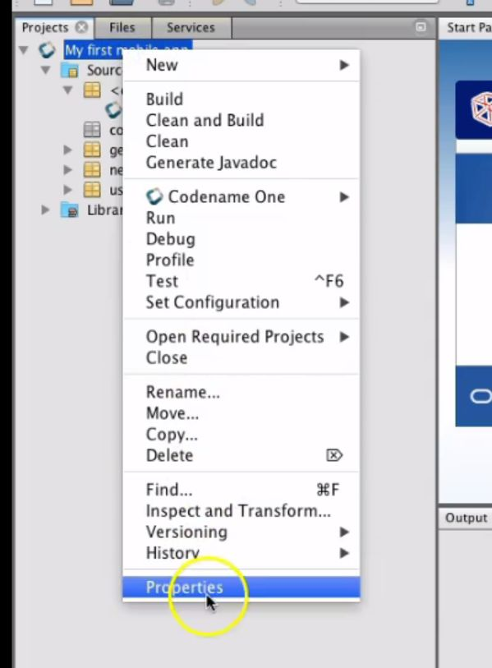

1. Right click here

Level of difficulty:   
Estimated time: 45 mn

2. Select « Properties »

1. 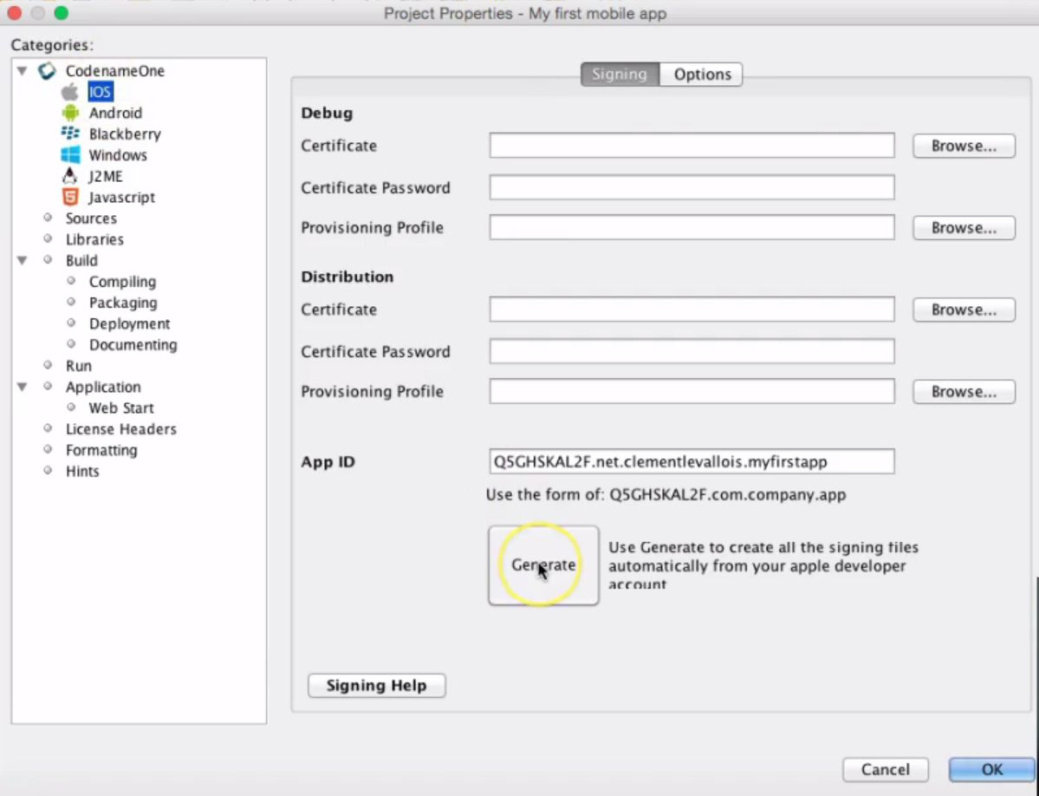Then we click on « iOS », then on « Generate ». We are going to generate the certificates for your app : the ones to install the app on your phone, but also to distribute the app on the Apple Store :

[**www.codapps.io**](http://www.codapps.io)by Clement Levallois **@codapps_io** [**www.coursera.org/learn/codapps**](http://www.coursera.org/learn/codapps)



**Module 4: Testing your app on a phone and distributing it**

*How to test your app on an iOS phone*

1. click here

2. then here

The first screen asks for your iTunes Connect login and password. These are the same as your Apple Developer account.

Level of difficulty:   
Estimated time: 45 mn

**Module 4: Testing your app on a phone and distributing it**

*How to test your app on an iOS phone*

[**www.codapps.io**](http://www.codapps.io)by Clement Levallois **@codapps_io** [**www.coursera.org/learn/codapps**](http://www.coursera.org/learn/codapps)



1. In the next screen, choose « Add a new device ».Give it a name of your choice (« My iPhone 4 »…) and paste the UDID we had gotten from iTunes (see preceding steps).
2. If you see any window asking to overwrite existing certificates, choose « Yes ».
3. When asked, install or save the certificates on your computer, choose the folder of your NetBeans project. We are now done with creatin the certificates for your app !
4. In NetBeans, right click on the title of your project and select “Send iOS Debug Build”

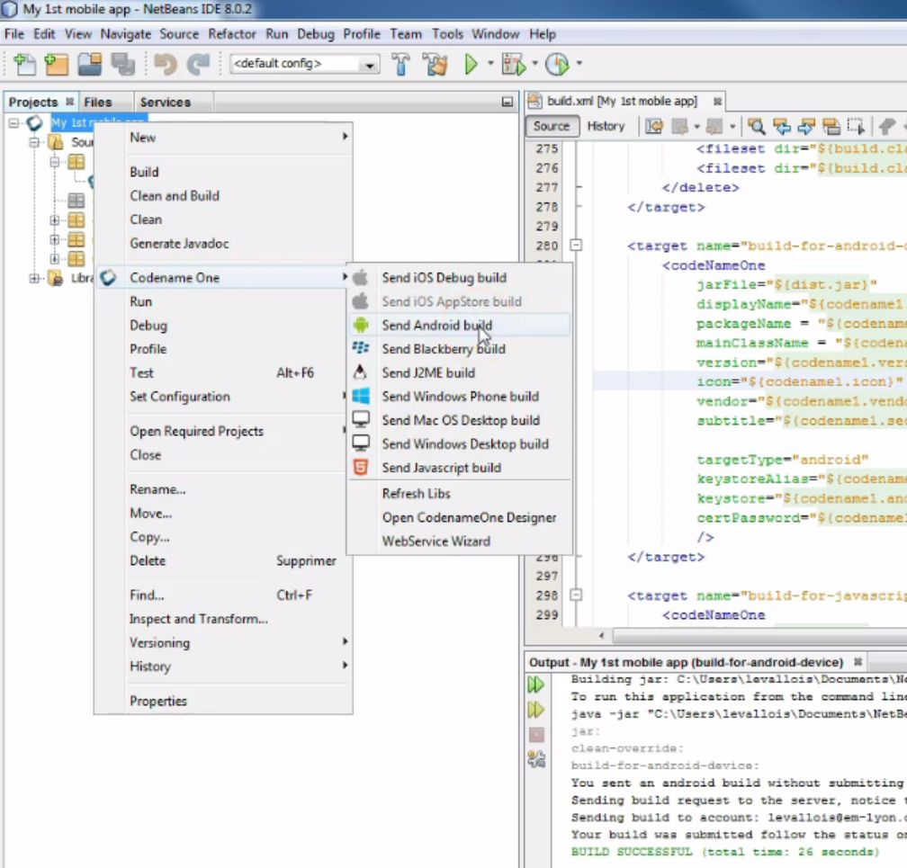

1. This starts the creation of package ready to be sent to Codename One. An alert windows will ask you for the login and password of your Codename One account, please enter them.

Level of difficulty:   
Estimated time: 45 mn

1. You know the process finished successfully when you see this in the bottom panel of NetBeans:

**Note**: you don’t see this output window at the bottom of NetBeans? In this case, in the menu of NetBeans, select “Windows” then “Output”, it should make it appear:

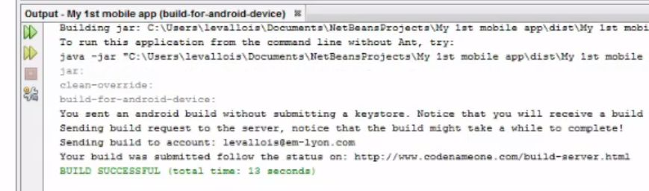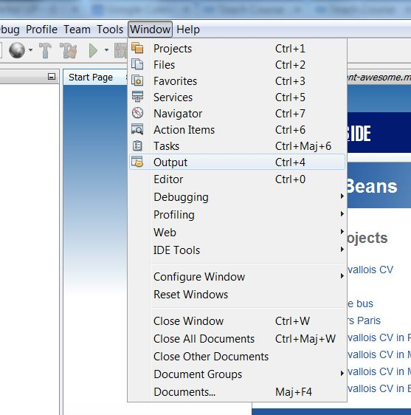

**Module 4: Testing your app on a phone and distributing it**

*How to test your app on an iOS phone*



[**www.codapps.io**](http://www.codapps.io)by Clement Levallois **@codapps_io** [**www.coursera.org/learn/codapps**](http://www.coursera.org/learn/codapps)



1. You can now go back to the website of Codename One, where your app has been sent to create the iOS version of it. Login, then go the the Dashboard (in the menu on top of the page).

Level of difficulty:   
Estimated time: 45 mn

1. You will see the status of your app:

* blue -> in progress
* green -> finished, ready to be used
* red: something went wrong, your iOS app could not be created.

1. When the status turns green, click on it. A series of option appears to install your app on your iOS phone:

* A QR code: flash the QR code from your iPhone, this will download the app on your phone and you’ll be able to install it.
* An email link: click here, and an email will be sent to the email address of your Codename One account. Open this email from your phone, click the link in it and this will start the download + installation process

[**www.codapps.io**](http://www.codapps.io)by Clement Levallois **@codapps_io** [**www.coursera.org/learn/codapps**](http://www.coursera.org/learn/codapps)



**Module 4: Testing your app on a phone and distributing it**

*How to test your app on an iOS phone*